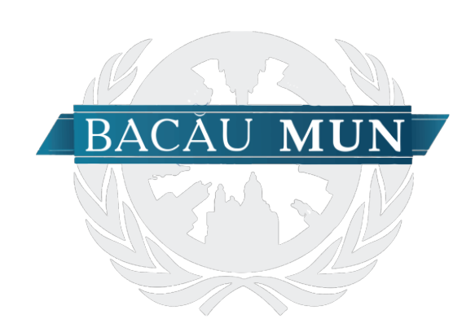

October 2018

Disarmament and International Security Committee

Chairpersons

Alexandra Anghel&Leonard-Petru Ciobanu

**Table of contents**

Welcome letter|pg.3

Introduction to the committee|pg.4

*Topic A|pg.4*

Definition of important terms|pg.4

Historical background|pg.5

Current situation|pg.7

International community and actions taken|pg.9

Parties implied|pg.11

Points adressed|pg.13

Further research|pg.13

*Topic B|pg.14*

Definition of important terms|pg.14

Historical background|pg.15

Current situation|pg.16

International community and actions taken|pg.18

Parties implied|pg.20

Points adressed|pg.21

Further research|pg.21

Honorable delegates,

It is our utmost pleasure to welcome you to the DISEC Committee. We would, firstly, like to congratulate you on being chosen to participate in this conference and, above all, for being chosen to be a part of this committee.

One of the main purposes of a chairperson is to provide their delegates with a strong base of knowledge that they will subsequently build upon in order to be able to further debate and find solutions while keeping in line with the policy of the countries that they are representing. It is an honour to us, therefore, to be able to serve as the chairs of the committee and aid you on your road towards a resolution.

This study guide has been created by us with this idea in mind, so we have tried our best (and hopefully succeeded to) make it as clear and easy to use as possible. This guide includes all of the basic information that is necessary for you to be able to understand the topics better and to be able to have a good idea of what you should be further researching on, so we would strongly recommend that you read it thoroughly. Furthermore, we invite you to raise any questions that you may have, as we would be more than happy to assist you.

We are sure that each of you possess great potential, thus, we are looking forward to meeting you in October and witnessing the development of your debates on the topics at hand.

Best regards,

Alexandra Anghel and Leonard-Petru Ciobanu

**Introduction to the committee**

**The Disarmament and International Security Committee** (DISEC) is the **First Committee of the United Nations General Assembly** (GA). The First Committee deals with disarmament, global challenges and threats to peace that affect the international community and seeks out solutions to the challenges in the international security regime.

It considers all disarmament and international security matters within the scope of the UN Charter or relating to the powers and functions of any other organ of the United Nations; the general principles of cooperation in the maintenance of international peace and security, as well as principles governing disarmament and the regulation of armaments; promotion of cooperative arrangements and measures aimed at strengthening stability through lower levels of armaments. The Committee works in close cooperation with the United Nations Disarmament Commission and the Geneva-based Conference on Disarmament. It is the only Main Committee of the General Assembly entitled to verbatim records coverage.

It includes all nations that are United Nations Member States. DISEC deals with issues regarding the promotion, establishment, and subsequent maintenance of global peace while simultaneously working to prevent weapons proliferation. Under the UN Charter, all member states and observers of the United Nations are automatically part of the first committee of the General Assembly, and have an equal vote. Documents drafted by this committee require a simple majority to be passed. Like the other committees of the United Nations General Assembly, DISEC is unable to impose sanctions, authorize armed intervention, or pass binding resolutions.

***Topic A: The Demilitarization of Crimea***

**Definition of important terms**

* **Disarmament:** The act of laying down arms, especially the reduction or abolition of a nation’s military forces and armaments
* **Annexation:** the formal act of acquiring something (especially territory) by conquest or occupation
* **Referendum:** a vote in which all the people in a country or an area are asked to give their opinion about or decide an important political or social question
* **Rebel:** (Government, Politics & Diplomacy) to resist or rise up against a government or other authority, esp by force of arms
* **Separatist:** someone who is a member of a particular race, religion, or other group within a country and who believes that this group should be independent and have their own government or in some way live apart from other people
* **Dissident:** a person who publicly disagrees with and criticizes their government
* **Sanction:** an official order, such as the stopping of trade, that is taken against a country in order to make it obey international law

**Historical background**

Ukraine is located in the Eastern part of Europe bordering Belarus, Hungary, Moldova, Poland, Romania, Russia and Slovakia, with a population of approximately 44.3 million people (45.4 million including Crimea). Territorially it is the largest country in Europe. After the collapse of the Soviet Union it has maintained close economic ties with Russia, and Ukrainian exports to Russia amounted to USD 15.8 billion in 2013. It provides approximately 5% of Russia’s total imports – the largest share amongst the Commonwealth of Independent States (CIS) and the fourth largest overall. Ukraine is also a transit state for Russian gas being delivered to Europe. Russia’s Black Sea Fleet, one of five divisions of the Russian Navy, is based in Sevastopol, Crimea.

Ukraine has historically been divided into Eastern and Western parts, which differ greatly in ethnic compositions, political orientations and identity. Thus, the Eastern part of the country has a Russian-speaking majority, whilst the Western part consists of Polish, Moldovan and Hungarian speakers and other national minorities, all within the stronger Ukrainian identity . This divide has played a significant role in several domestic issues, including the strengthening of the Ukrainian language, which has been taking place since the breakup of the Soviet Union and has further divided the two regions of the country. This divide has been especially apparent since a pro-Western government came to power in 2005, which was widely contested in the Eastern part. The divide is at the very root of the current conflict.

Ukraine gained independence on the August 24, 1991. It maintained very close ties to Russia until 2004, when the term of the second Ukrainian president, Leonid Kuchma, expired. The subsequent first round of presidential elections led to two candidates, Viktor Yushchenko, known for his pro-Western attitude, and Victor Yanukovich, who intended to maintain and develop close ties with Russia.

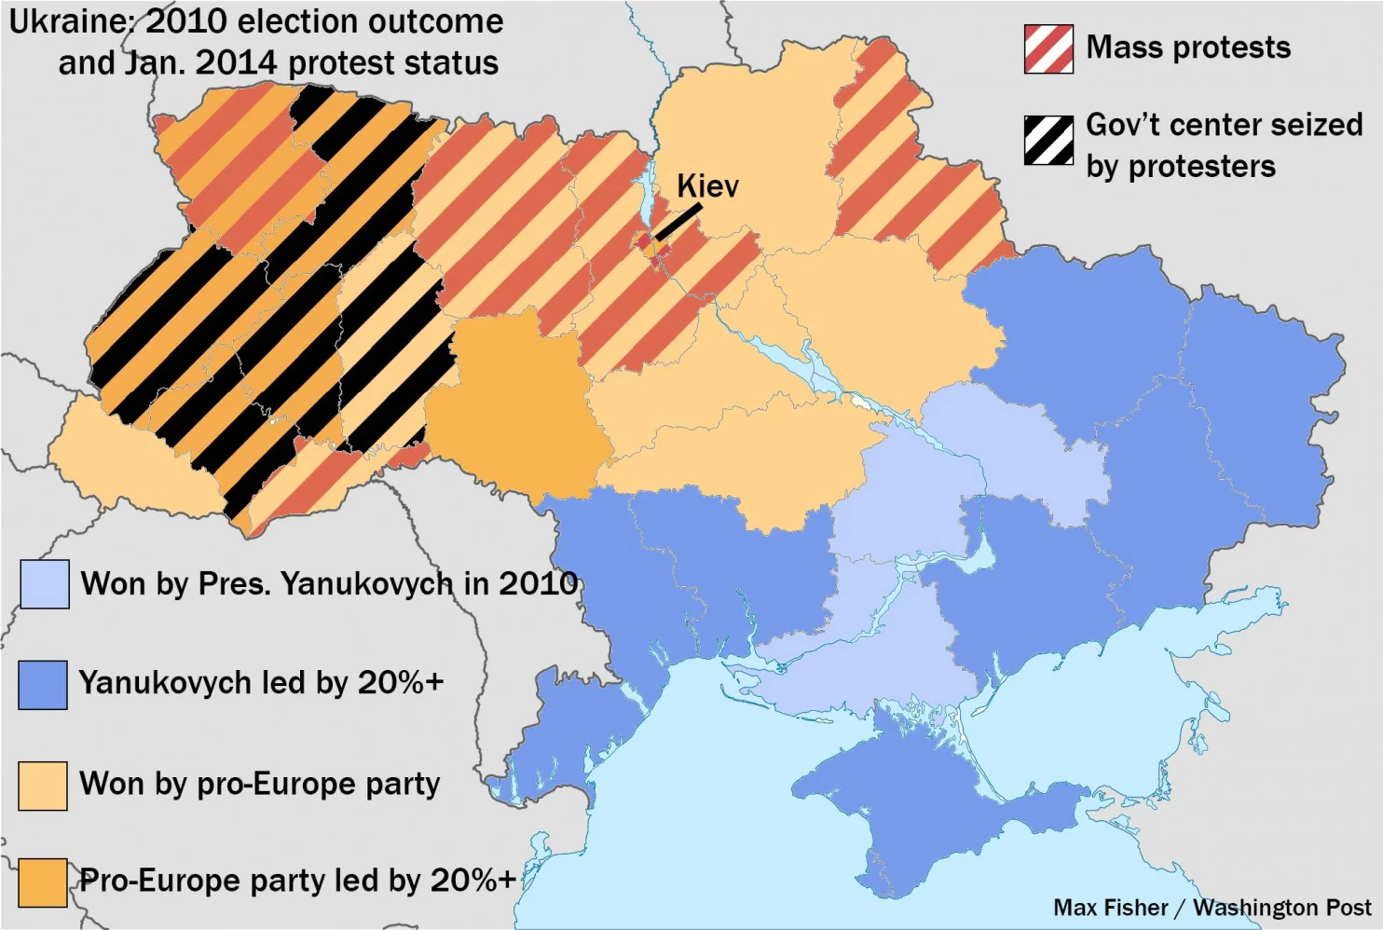

Subsequently, the fact that Yanukovich was leading in the polls of the second round of elections in November 2014, caused protests in the country. The events led to election re-runs and the victory of the pro-Western candidate Yushchenko (2005-10). After his turbulent term expired in 2010, the pro-Russian candidate Yanukovich took office and pledged to maintain pro-Western commitments made by the previous president (2010-14).

Recent events started in November 2013 when, under significant pressure from Russia, the Ukrainian president abandoned further cooperation with the European Union (EU) by refusing to sign an EU-Ukraine Association Agreement, which would have guaranteed a free-trade zone and potentially a trade corridor for Russia. The protests in Maidan Nesalezhhnosti (Independence Square) in Kiev escalated to a full-scale revolution. Russia condemned the protesters as fascists and neo-nazis, whilst the European Parliament and the US government issued their support to the Euromaidan wave of demonstrations and unrest and its struggle against the Yanukovich government. In February 2014, 77 people were shot in Independence Square, which led to the president stepping down and fleeing to Russia, even though a government-opposition agreement was concluded shortly before.

Events intensified in March 2014, when the “Little Green Men”, soldiers of an unknown origin (presumably, Russian), entered the Crimean Peninsula and helped local separatist forces take power in the region, and conducted a referendum on its political status. This referendum resulted in the annexation of the Crimean Republic by Russia. This was deemed illegitimate by the Ukrainian government and the international community, as it broke the Budapest Memorandum of 1994 between the USA, the UK, Ukraine and Russia , guaranteeing the territorial integrity of Ukraine. It was at this point that the EU and the USA first imposed economic sanctions on Russia. The success of the separatist movement in Crimea inspired separatists in two other regions, those of Donetsk and Luhansk respectively, to move forward with their own agendas. This caused an outbreak of military conflict on the Russian border, and when a businessman, Petro Poroshenko, won the presidential election of May 2014, who was overwhelmingly supported by the USA and the EU, military action intensified in these breakaway regions. Furthermore, the crash of the commercial airliner MH17 over the Donetsk region, in which 298 passengers were killed, drew the full attention of the UN and the international community, and subsequently led to further sanctions being imposed upon Russia.

**Current situation**

1. **Donetsk and Luhansk**

The situation in the Eastern regions of Donetsk and Luhansk bordering Russia started to develop in the beginning of April 2014, when protesters, commonly named by the media as pro-Russian separatists, occupied government buildings in Donetsk, Luhansk and Kharkiv (with the latter not as violent as the other two). Protesters, inspired by events in Crimea, demanded independence referendum and the protection of Russia. In May, the separatist groups established themselves as the governments of ‘Donetsk People’s Republic’ and ‘Luhansk People’s Republic’. These newly formed governments held referenda, declared their independence and applied to join Russia. The applications were never acknowledged by the Russian Parliament nor addressed by the government. The Russian Foreign Minister, Sergei Lavrov, did, however, admit to providing assistance to the separatists.

In May 2014, the newly elected Ukrainian president, Pedro Poroshenko, established military operations in these regions, including the seizure of the airport in Donetsk, leading to heavy casualties on both sides. Throughout May and June, separatist groups expanded their territories, and occupied two strategic military bases in the Luhansk region and shot down several Ukrainian military planes.

On June 27th, an EU-Ukraine Association Agreement was signed, which caused dissatisfaction from the Pro-Russian side and led to a violation of the ceasefire adopted previously. In July, however, the Ukrainian government soldiers regained territories and military bases. The separatists retaliated by stepping up their efforts in shooting down several military planes . On July 17th, the separatists shot down the commercial airliner MH17, flying from Amsterdam to Kuala-Lumpur, with 298 people on board. The plane was shot down using Soviet-era equipment, making it difficult to establish its source. According to the preliminary investigation, the plane was shot down by mistake and there was no direct evidence of Russia’s involvement. This incident drew the full attention of the international community to the situation in the breakaway regions and led to further sanctions against Russia from the USA and the EU.

On the October 24, 2014 during a UNSC meeting, the Assistant Secretary General on Human Rights, Ivan Šimonović, informed the Council that the death toll during the conflict had reached 3700 people, which represented a notable increase since the previous report released by the United Nations in August (2200 victims). By November 14th, the death toll had reached more than 4100 people, with more than 9000 people wounded and around a million people displaced. In October 2014, Mr Šimonović stated that the current peace arrangements were moving too slowly and encouraged the Security Council to “to work more urgently towards durable peace”.

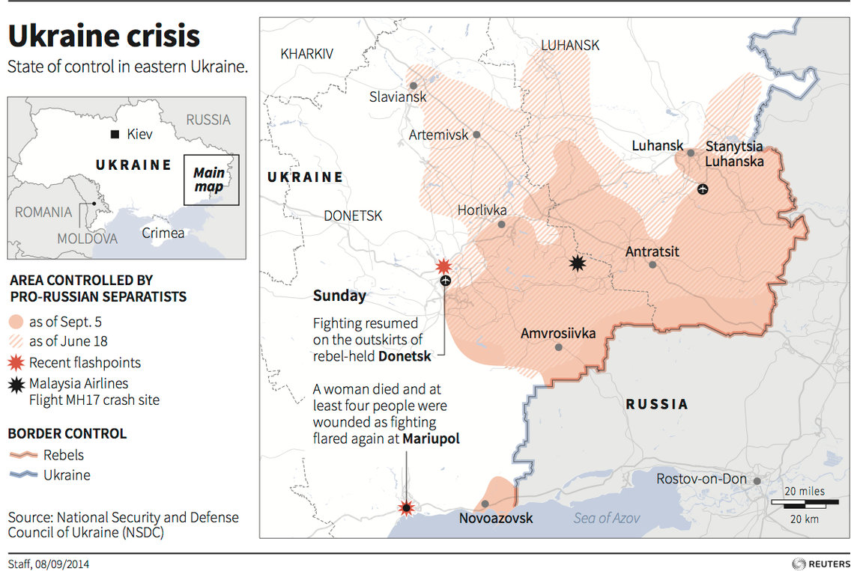

**B. Geopolitical instability caused by the situation in Ukraine**

The crisis is one of the biggest geopolitical threats in Europe since the breakup of Yugoslavia. It is not definitively known whether the Ukrainian conflict can be considered as an international conflict, as Russia has not officially taken any responsibility for any major military involvement, nor any other actions as alleged by the international community. However, the geopolitical importance of the country, and Russian interest in Ukraine, has turned the country into a battleground between Russia and NATO.

The tensions started with the annexation of Crimea by Russia and the appearance of the ‘green people’, the soldiers in unmarked uniforms that helped the separatists seize power in the first place. Their presence increased further with continued military operations in the two breakaway regions of Donetsk and Luhansk and multiple exercises by the Russian Army near the southern borders in the summer of 2014. NATO conducted military training in September in the Lviv Region in the Western part of Ukraine (Operation Rapid Trident) at the same time that peace talks took place in Minsk. Russia, allegedly, sent its soldiers to fight on the side of the separatists in the Donetsk and Luhansk regions, as well as initiating five humanitarian aid convoys (as of the beginning of November 2014), which were initially regarded as an undercover invasion of Ukraine. Events escalated further in November 2014, when the Ukrainian government sent military troops to protect the occupied cities. ;According to NATO, Russia has moved its troops to the separatist-occupied territories. The Russian Government has however denied this action. This action has increased tensions further and is reminiscent of cold war proxy wars.

Analysts say that Russia’s main long-term goal has been to re-establish itself in the former Soviet space and as a global power. Supported by state propaganda, in the summer of 2014, government approval ratings reached 87%. NATO is expanding eastward and, after the accession of the Baltic States and Poland, is now currently bordering Russia . Russia is not invited to G8 summits, which deprives the leaders of a platform to discuss issues and is reminiscent of a cold war attitude. If further escalation occurs, the events may lead to a wider hot conflict between the two sides. The atmosphere escalated further when several Russian military planes were discovered by radar equipment in different parts of the EU, from the Baltic States all the way to the UK. In addition to this, the Ukrainian President alleged that President Putin stated in a private telephone conversation that if he wanted to, “Russian troops could, in two days, be not only in Kiev but also in Riga, Vilnius, Tallinn, Warsaw, and Bucharest” . Considering the fact that all interested parties have nuclear arsenals at their disposal, the international community is doing its best to ensure the conflict does not escalate further, particularly to a level of interstate war.

**International community and actions taken**

The UN, EU, and Ukraine have stated on multiple occasions, that there is “no military solution” to the conflict. There are indeed several possible outcomes to the conflict, all of them, however, requiring military de-escalation in Donetsk and the withdrawal of Russian troops from the region.

The first solution would be that the breakaway regions remain part of Ukraine and leaving the country’s territorial integrity intact. They will however gain a greater autonomous status. Some also suggest that Ukraine could change its constitution and obtain a neutral status based on a Finnish or Austrian model.

The Boisto group, consisting of “American and Russian experts and former officials—including an ex-director of Russia’s Foreign Intelligence Service and a top Russia advisor to George W. Bush” met in Finland in August and produced a 24-step plan to resolve the conflict. The plan includes establishing a ceasefire by ensuring the retreat of both Ukrainian and Russian military forces, establishing a UN peacekeeping operation, and demilitarization amongst other things. The governments involved however, have not considered this plan.

At the end of September 2014, the presidents of Russia, Ukraine, Belarus, the Chancellor of Germany as well as the representatives of the self-proclaimed governments of the Donetsk and Luhansk regions gathered in Minsk, Belarus, for peace talks. President Poroshenko has claimed that these were “tough” talks, but no substantial long-term agreement was reached. The parties agreed to establish a 30-km buffer zone and a ceasefire, which was violated multiple times soon afterwards.

The leaders of Ukraine, Russia and members of the European Council (the heads of the EU governments) met in Milan in October 2014 to discuss the situation with regards to the security of the gas supply to Ukraine and to the EU. The gas situation stabilized, however the conflict remains unresolved . Meetings between the president of Russia and the heads of the EU Member States were held during the G20 Summit in November 2014. However, no further significant progress has been made. The EU has warned Russia of further sanctions.

**Parties implied**

***Russian federation***

Russia considers Ukraine to be one of its closest allies and a ‘brother nation’. Kiev used to be the capital of the Kievan Rus’, which was the cradle of the Slavic culture and religion. Over the course of the last few years, the Russian government has done all it could to keep Ukraine close by carrying out various actions, including economic deals and adding further pressure on gas prices, and the alleged poisoning of President Yushchenko in 2004. Throughout the current conflict, Russia has strongly supported Yanukovich and has granted him asylum. Russia recognizes the current president, as well the governments of the Donetsk and Luhansk regions. In March 2014, Russia annexed the region of Crimea in order to ‘protect the Russian-speaking population in Crimea’ (which constitutes approximately 60% of the total population of the region). Russia is strengthening its armed forces around the southern borders of the region and, allegedly, is sending its troops to the breakaway regions, without officially recognizing the fact of doing so. In light of economic sanctions, Russia is developing ties with Asian economies, such as concluding a USD 400 billion-gas contract with China . On September 3rd ,prior to the Welsh NATO Summit and the Minsk talks, President Putin proposed a 7-point plan to end the conflict, which was not widely regarded by any of the parties involved . Due to the economic sanctions placed on Russia, the falling price of oil, and a drop in the rouble against the US dollar, Russia has fallen into recession.

***The United States of America***

The USA has strongly supporting the Euromaidan movement from the very beginning. It has strongly condemned the actions of Russia in Crimea and Eastern Ukraine. It has imposed economic sanctions on Russia as well as depriving the country of the trade privileges. President Obama has stated on multiple occasions that the aggressive actions of President Putin are threatening the post-WWII world order. He has ensured the US has maintained its support for NATO allies, specifically for the Baltic states and promising to “thwart Russia’s “dark tactics” and territorial ambitions, should they spread from Ukraine to those NATO allies to the north”.

***NATO***

NATO believes that a sovereign, independent and stable Ukraine, firmly committed to democracy and the rule of law, is key to Euro-Atlantic security”. The cooperation, which was created in 1991, has strengthened in light of the current conflict, and NATO is determined to support Ukraine’s territorial integrity and sovereignty. Ukraine is a long-standing partner of NATO and is part of some of the Alliance’s programs. At the Bucharest Summit in April 2008, NATO leaders agreed that Ukraine might become a NATO member in the future. During its summit in Wales on September 4th, Allied leaders issued a statement pledging to further support the Poroshenko government, strengthening its military capacities and insisting that Russian forces retreat from Ukraine.

***The European Union***

The EU remains supportive of the new Ukrainian government and its pro-Western politics. They have introduced several rounds of sanctions affecting Russian oligarchs and the people close to President Putin. These sanctions, however have not affected the gas trade between the EU and Russia, and the EU is seeking ways to reduce dependency on Russian gas. In the meantime, the EU and Angela Merkel, in particular, are playing an important role in mediating interactions between Ukraine and Russia.

***China***

China remains a neutral side in the conflict, and pursuing its own economic interest. It is Russia’s partner in BRICS, and is considered “the biggest winner” in the crisis. The crisis has helped China strengthen economic ties with Russia, as well as giving the country a stronger stance in Asia in light of US-Russia tensions. It holds a low-key position and seeks a negotiated solution.

***India***

A longstanding ally of Russia and a partner in BRICS. In March 2014, India issued a statement referring to Crimea, and stated that Russia’s interest in Ukraine was legitimate. Although not comfortable with the annexation of Crimea, India supports the strength of the Russian president who has defending his country’s interests and close ties with the region. President Putin publicly thanked India for its “restraint and objectivity” regarding the crisis . The Indian government hasalso issued a statement congratulating Mr. Poroshenko on his election as president. India has taken the strengthening of ties between Russia and China into consideration, but does not favor Russian interference in the Donetsk and Luhansk regions. It seeks a balanced solution to the crisis. According to Ranjit Gupta, a former member of the Indian National Security Advisory Board, “India’s stance in relation to events in Ukraine has been somewhat ambiguous and decidedly nuanced, but admittedly tilted in favor of Russia”.

**Points adressed**

1. What actions can the DISEC committee take in order to assure complete demilitarization of Crimea?
2. What international and regional action should be taken in order to deal with separatist forces in eastern Ukraine?
3. How can a sustainable ceasefire be achieved?
4. What incentives could be given to the parties involved to stop the conflict?
5. Are international sanctions on Russia justified?
6. How can the tensions in Ukraine be effectively reduced?

**Further research**

* <https://www.cia.gov/library/publications/theworldfactbook/geos/up.html>
* <https://en.wikipedia.org/wiki/Annexation_of_Crimea_by_the_Russian_Federation>
* <http://www.nytimes.com/2013/12/11/world/europe/kerrys-statement-onukraine.html?_r=1&>
* <http://blogs.telegraph.co.uk/news/charlescrawford/100262865/vladimir-putins-illegal-occupation-of-crimea-is-an-attempt-to-put-europes-borders-up-for-grabs/>
* <https://web.archive.org/web/20140305020550/http://www.kyivpost.com/content/ukraine/what-parts-of-the-black-sea-fleet-agreement-is-russia-violating-338358.html>
* <https://web.archive.org/web/20140325194933/http://www.cbsnews.com/news/ukraine-troops-leave-crimea-by-busload-defense-minister-resigns-after-russia-seizes-peninsula/>
* <https://www.bbc.com/news/world-europe-26532154>
* <https://www.cfr.org/arms-control-disarmament-and-nonproliferation/budapest-memorandums-security-assurances-1994/p32484>
* <https://www.securitycouncilreport.org/un-documents/ukraine/>
* <https://www.nytimes.com/2014/03/16/world/europe/russia-vetoes-un-resolution-on-crimea.html>
* <https://www.theguardian.com/world/2014/sep/02/ban-ki-moon-no-military-solution-ukraine>
* <https://ec.europa.eu/commission/news_de>
* <https://www.independent.co.uk/news/pictures/david-cameron-and-vladimir-putin-have-frank-exchange-in-talks-but-no-breakthrough-over-ukrainian-9862784.html>
* <https://www.theatlantic.com/international/archive/2014/08/a-24-step-plan-to-resolve-the-ukraine-crisis/379121/>

***Topic B: The Establishment of a Nuclear Weapon Free Zone in the Middle East Region***

**Definition of important terms**

**Nuclear-Weapon-Free Zone (NWFZ)** - A nuclear-weapons-free zone (NWFZ) is defined by the [United Nations](https://en.wikipedia.org/wiki/United_Nations) as an agreement which a group of states has freely established by treaty or convention that bans the use, development, or deployment of nuclear weapons in a given area, that has mechanisms of verification and control to enforce its obligations, and that is recognized as such by the General Assembly of the United Nations. NWFZs have a similar purpose to, but are distinct from, the [Treaty on the Non-Proliferation of Nuclear Weapons](https://en.wikipedia.org/wiki/Treaty_on_the_Non-Proliferation_of_Nuclear_Weapons) to which most countries including five nuclear weapons states are party.

**Nuclear- free zone (NFZ)** - nuclear-free zone, often means an area which has banned both nuclear power and nuclear weapons, and sometimes nuclear waste and nuclear propulsion, and usually does not mean a UN-acknowledged international treaty.

**Treaty on the Non-Proliferation of Nuclear Weapons**- The Treaty on the Non-Proliferation of Nuclear Weapons, commonly known as the Non-Proliferation Treaty or NPT, is an international treaty whose objective is to prevent the spread of nuclear weapons and weapons technology, to promote cooperation in the peaceful uses of nuclear energy, and to further the goal of achieving nuclear disarmament and general and complete disarmament

**Historical background**

The introduction of a nuclear weapon free zone is a regional approach to strengthen global nuclear non-proliferation and disarmament norms, and also to consolidate international efforts towards peace and security.

The concept of a zone free of nuclear weapons has been crucial in the creation of disarmament and reduction of regional conflict. A nuclear-weapon free zone was first suggested by the Polish Foreign Minister Adam Rapacki at the United Nations General Assembly, way back in October 1957, and it has since become an important concept in disarmament and maintenance of world peace. A nuclear weapon free zone in the middle east has always been a long-debated topic, mainly due to the fear of the emergence of a nuclear arms race in the region as a consequence of complex conflicts in the region. With Iran’s nuclear programs and Israel’s nuclear policies, the establishment of a nuclear weapon free zone is seen as vital. It is said to be a peaceful way of settling of issues in the region and providing security.

The United Nations General Assembly (UNGA) first endorsed calls for the establishment of a NWFZ in a resolution approved in December of 1974 following a proposal by Iran and Egypt, in an effort to roll back Israel’s acquisition of nuclear weapons and to restrain further proliferation in the region, by having all states join both a NWFZ and the nuclear Non-Proliferation Treaty (NPT).

In the beginning, Israel abstained in the vote on the Egyptian initiative but as of 1980 it joined in adopting the annual UN General Assembly resolutions on this matter by consensus, which was one of the reasons that prompted Egypt to ratify the NPT in 1981. The resolution has then been passed annually by the UNGA and opened the doors to the negotiations regarding the setting up of the zone, which are still in progress to date. Ever since presenting its resolution to the UNGA, Egypt has been a very strong supporter of the establishment of the nuclear weapon free zone in the middle east and has, along with other countries, put pressure on the other Middle Eastern states to establish a nuclear weapon free zone, mainly to tackle the ever-growing interest of the Israeli government in developing its nuclear weapon programs and its ambiguous nuclear policies.

The UN Security Resolution 687 recognised the establishment of the “Middle Eastern Nuclear-Weapon-Free Zone” (MENWFZ) as a goal. On 9th Dec 1975, the UN passed a resolution (3236), calling for a MENWFZ. In 1975 for the first time, an agenda for the establishment of such a zone was acknowledged by the United Nations. There have been many more resolutions passed since that period.

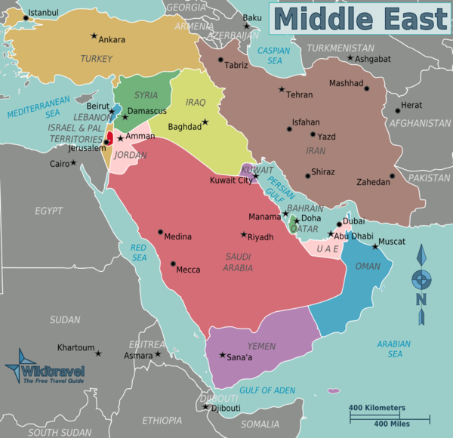

**Current situation**

The Middle East is a conflict prone zone, and it is important, when considering to establish a Nuclear Weapon Free Zone, to understand some of the conflicts that are currently present.

Take, for example, the **Israeli-Iranian tensions**. Ever since Iran suffered a change in government, so did the relationship between the two countries. The conflict is bound in the political struggle of Iranian leadership against Israel and its declared aim to dissolve the Jewish state, with the counter aim of Israel to prevent nuclear weapons being acquired by the Iranian government and downgrading its allies and proxies such as the Lebanese Hezbollah party. The most recent developments took place on May 9, 2018, when a multiple-rocket launcher system operated by the Quds force—an expeditionary special forces unit of the Iranian Revolution Guard Corps—fired a salvo of twenty unguided 333mm Fajr-5 rockets towards Israel.

One other noteworthy example would be the **Arab-Israeli conflict**. The roots of this conflict stand in the beginning of the 20th century, when Arabs began to develop a sense of national identity as Palestinians, later referred to as “Arab Nationalism”. At the same time, as Jews faced persecution in Europe, Zionism, the call for an independent Jewish state of Israel, becomes more and more popular with Jews in the area. As the Ottoman Empire fell, Britain and France divided the Middle East, with Britain claiming modern day Israel. As tensions between Arab Nationalists and Zionists begin to grow, Britain passes the territory to the UN at the end of the Second World War.

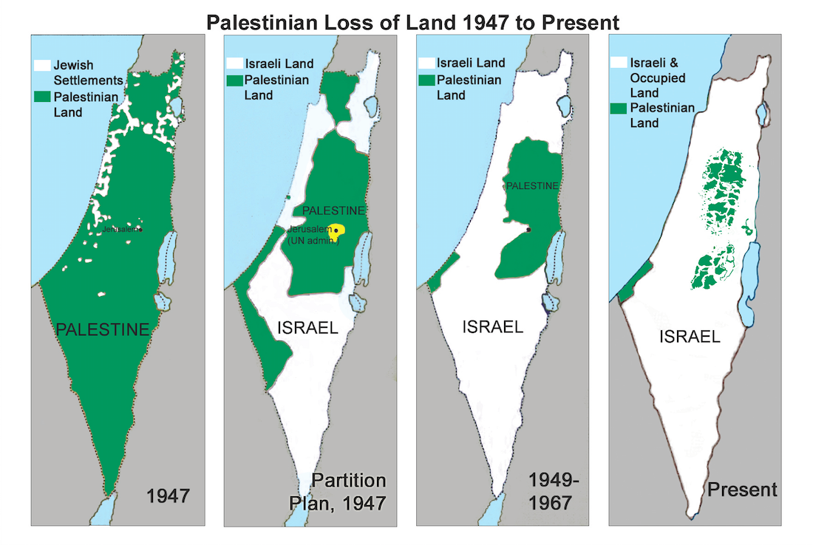

The newly formed United Nations in 1948 divides the territory on ethnic/ religious lines, with Israel providing an independent Jewish state for the Zionists, and Palestine as a free state for Arab Nationalists. However, many Arab neighbours view the UN ruling as imperialistic given that the number of Arabs in the area far outweighs the number of Jews. Arab Nations invade in 1948 to unite the territory under Palestinian rule . They are unsuccessful, however, and Israel expands its territory significantly, overstepping the UN ruling. The expansion of Israeli territory, therefore, is why Arab states have bad relations with Israel.

At the same time, Israel is surrounded by potential enemies and will take necessary steps to protect itself against foreign invaders.

Besides, countries such as **Iran and Saudi Arabia** do not have diplomatic relations and, although they have not declared war, the tensions between them are not to be overlooked.

**Parties implied**

**Israel**- Israel has an ambiguous policy regarding its nuclear weapons program. Israel does not confirm or deny having nuclear weapons, but experts suggest Israel has approximately 80 nuclear missiles. Israel has held on to its nuclear weapons, refused to join the NPT, significantly expanded its stockpile of fissile material for weapons and developed advanced delivery systems.

**Egypt**- Although pursuing a vast ballistic and biological weapons program, Egypt has worked towards a nuclear free Middle East. Egypt is the leading proponent of the zone in the Middle East

**Sunni Arab countries** such as **Saudi Arabia**, **Iraq** and **Jordan** worry over the possibility of a growing arms race in the Middle East. Although diplomatic relations between Israel and the Gulf states are poor, both blocs are united in their opposition to an Iranian nuclear weapons program.

The recent Iranian Nuclear Weapons deal did not reassure Arab states, as Arab leaders are not convinced that Iran’s intentions are peaceful. As a result, both **Saudi Arabia** and the **UAE** are heavily militarizing,

**Iran**- Despite being a signatory to the NPT, Iran’s nuclear program has led to political tensions across the Middle East. Although the Iranian government claims its nuclear program is for energy and thereby “peaceful” purposes, neither the Gulf states or Israel seem convinced. Furthermore, internal divisions have grown over the program due to increasingly heavy sanctions from greater powers. This means that Iran takes a cautious approach, so called “nuclear hedging”. Given that Iran is surrounded by nuclear powers, it hopes to keep the possibility of a nuclear weapons program open if it needs it, whilst avoiding escalating tensions with Saudi Arabia.

**Nuclear power states:**

**Trump** has aligned himself with the Sunni-Gulf states and Israel in opposition to the development of Iranian weapons. Although Trump is ambivalent about the deal, Washington has been keen to strictly enforce regulations on Iran as part of the deal, in order to prevent the development of Iranian weapons of mass destruction.

**The UK** unlike the US is not only more enthusiastic about the nuclear deal but has condemned the Israeli settlers in Palestine . Despite this, the UK has acknowledged the destabilizing effect Iran has had in the region, and thus aligns itself with the Sunni states and Israel.

These sentiments are also echoed by **France**, who also supports Israeli security. **Russia** too acknowledges that although it has supplied Iran with arms, the implications of nuclear conflict in the region are disastrous for maintaining Moscow’s influence. As of such, Moscow has been willing to maintain dialogue with both Iran and Israel as it acknowledges them as key players in the region .

**China** believes that nuclear proliferation in the Middle East is a consequence of a failed peace process between Middle Eastern states. China recommends that in order to achieve disarmament, an ongoing process of reconciliation should begin between Israel, Iran and Sunni states over territorial disputes.

**International community and action taken**

There already are some nuclear weapon free zones in the world. The following section will discuss them.

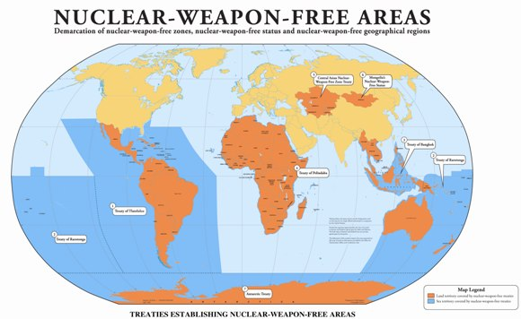

**a.The 1996 African Nuclear Weapon-Free Zone Treaty**

The topic of a nuclear weapon free zone in the area started when the Organization of African Unity stated its interest in the establishment of such a zone in 1964. This was to combat the French testing in the Saharan region, and the growing interest of nuclear weapons for security by the apartheid regime in South Africa. The Treaty of Pelindaba was signed in 1997 and came into effect in 2009. All states in Africa are eligible to be part of the resolution. In 1996, no African Arab state was willing to ratify the treaty until Israel gave up its nuclear weapon program. Algeria, Libya and Mauritius have ratified their treaty since then.

**b. The 1967 Treaty for the Prohibition of Nuclear Weapons in Latin America and the Caribbean**

French nuclear weapon testing in the Sahara in the 1960s and the South African apartheid regime’s interest in nuclear arms, led the African states to issue a call for an African NWFZ, which was endorsed by the UN General Assembly in 1961. Brazil was the only Latin American state, at that time, that supported the African NWFZ resolution and proposed a similar zone within its region. The treaty of Tlatelolco is a treaty was passed and signed on the 14th of Feb 1967, and came into force on the 24th of Feb 1969. It was proposed by Costa Rica at an OAS meeting, as other proposals within the OAS regarding this had not been successful. The treaty covers the whole of the Latin American and Caribbean region, including sections of the Pacific and Atlantic Oceans, with all the 33 states in the region having signed and ratified the treaty.

**c. The 1985 South Pacific Nuclear Free Zone Treaty**

Following the nuclear denotation in Hiroshima and Nagasaki, the concern over the issue of nuclear weapons grew in the Asian Pacific region. The South Pacific Forum took up the issue in 1975 after New Zealand proposed the formation of a Nuclear Weapon Free Zone. The same year, UNGA endorsed the resolution. The Treaty of Rarotonga was opened for signature on the 6th of August, 1985, but entered into force on the 11th of December 1986.

**d. The 1995 Southeast Asia Nuclear-Weapon-Free Zone Treaty**

On the 27th of November 1971, the original 5 members of ASEAN signed the Declaration of an ASEAN zone of peace, freedom and neutrality in Kuala Lumpur. A major component of this was to establish a Nuclear Weapon Free Zone in the region. With about 10 years of negotiation, the Treaty of Bangkok was signed on the 15th of December 1995 and entered into force on the 28th March 1997.

**e. The 2006 Treaty on a Nuclear-Weapon-Free Zone in Central Asia**

The initiative started with Mongolia stating its goal to become a one-state nuclear weapon free zone in 1992. Mongolia also called for the establishment of a regional Nuclear weapon free zone. The first proposal was in 1993 to the UNGA. The treaty of Semipalatinsk was formed in 8th September 2006 and entered force in 2009. It has been signed and ratified by 5 states.

**Points addressed**

1. Which countries should be included in the zone? Would Turkey be a part of it?

2. How would the establishment of the Nuclear Weapon Free Zone happen?

3. How would a continued commitment to such a zone be achieved?

4. What would happen to the nuclear weapons in the area? How would they be discarded?

5. What would be the terms of the Nuclear Weapon Free Zone? Would it include development and research of nuclear powers, or just focus on the development of nuclear weapons?

**Further research**

<https://carnegieendowment.org/2016/07/07/realistic-approach-toward-middle-east-free-of-wmd-pub-64039>

<http://www.un.org/en/conf/npt/2010/pdf/daisyalliance.pdf>

<http://www.nonproliferation.eu/web/documents/other/heinzgartner4ec66bd720848.pdf>

<http://www.corteidh.or.cr/tablas/r33473.pdf>

<https://www.aljazeera.com/indepth/opinion/2013/01/2013141248927573.html>

<https://www.armscontrol.org/factsheets/mewmdfz>

<https://nationalinterest.org/blog/the-buzz/how-the-proxy-war-between-iran-israel-started-25879>

<https://en.wikipedia.org/wiki/Treaty_on_the_Non-Proliferation_of_Nuclear_Weapons>